# Network Modeling of the Campus of University of Washington

**Step 1: Determine the research boundary and download .osm file from OpenStreetMap**

Adjust the map to the location of interest and click on the Export button on the top.

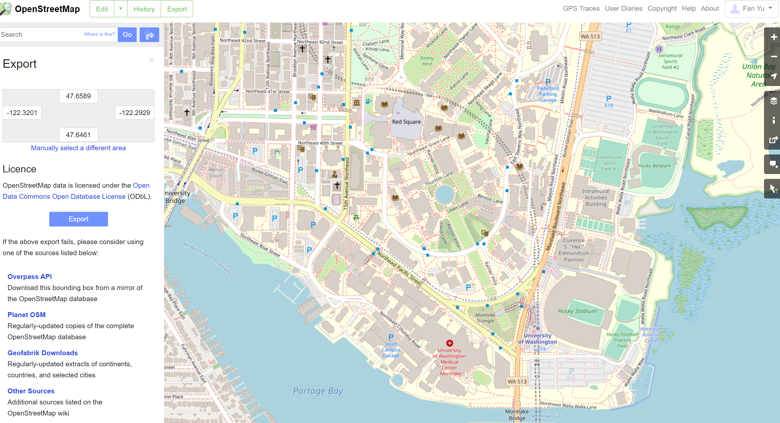

Then, obtain the latitude and longitude coordinates of UW campus. Lastly, click on the Exportbutton found in the middle of the navigator to download an OSM data file.



**Step 2: Execute OSM2GMNS to get network files in GMNS format**

Open the Python IDE such as Pycharm for a typical configuration. Then, OSM2GMNS converts *map.osm* file in OSM format into a network file in GMNS format.

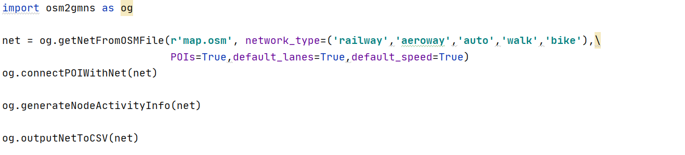

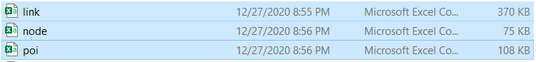

**Step 3: Execute GRID2DEMAND Python code**

Configurate working dictionary in the Python IDE (e.g., Pycharm). Then, execute GRID2DEMAND to get zone-to-zone demand, generating four files which are highlighted in blue.

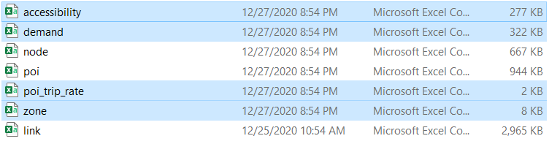

**Step 4: Visualization in QGIS**

Open QGIS and add Delimited Text Layer of the output files.

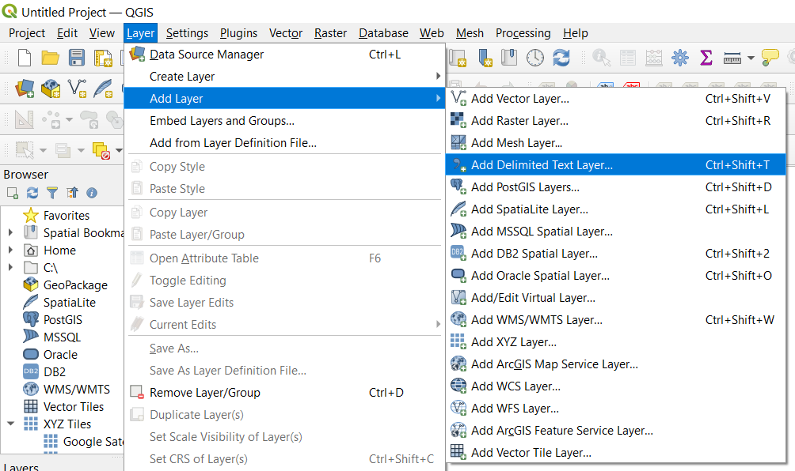

Then Open the Properties window of the demand layer. Set the symbology as graduated symbols by size.

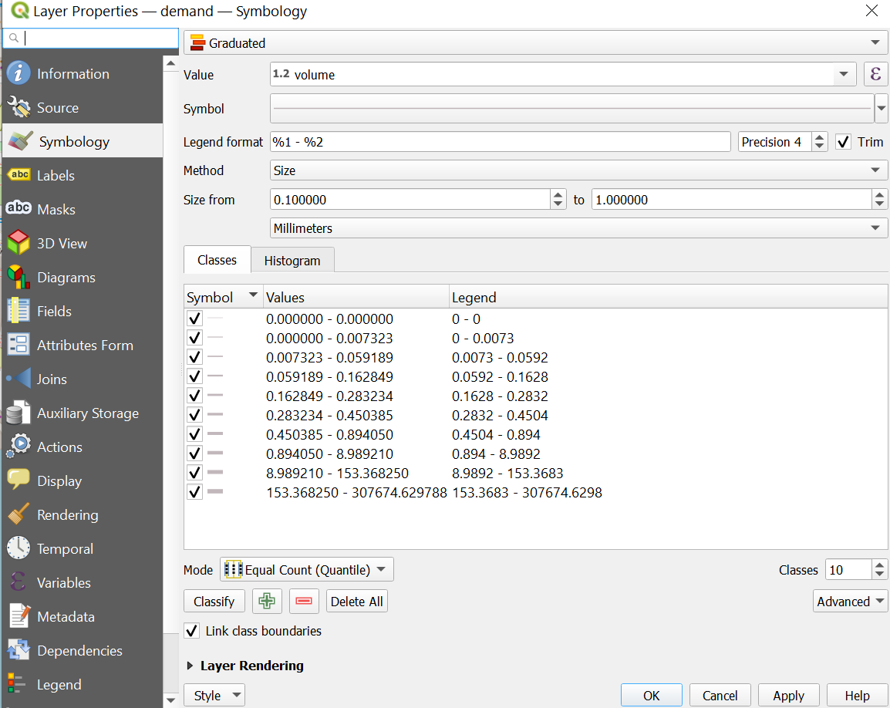

Zone-to-zone demand can be visualized with a base map of University of Washington

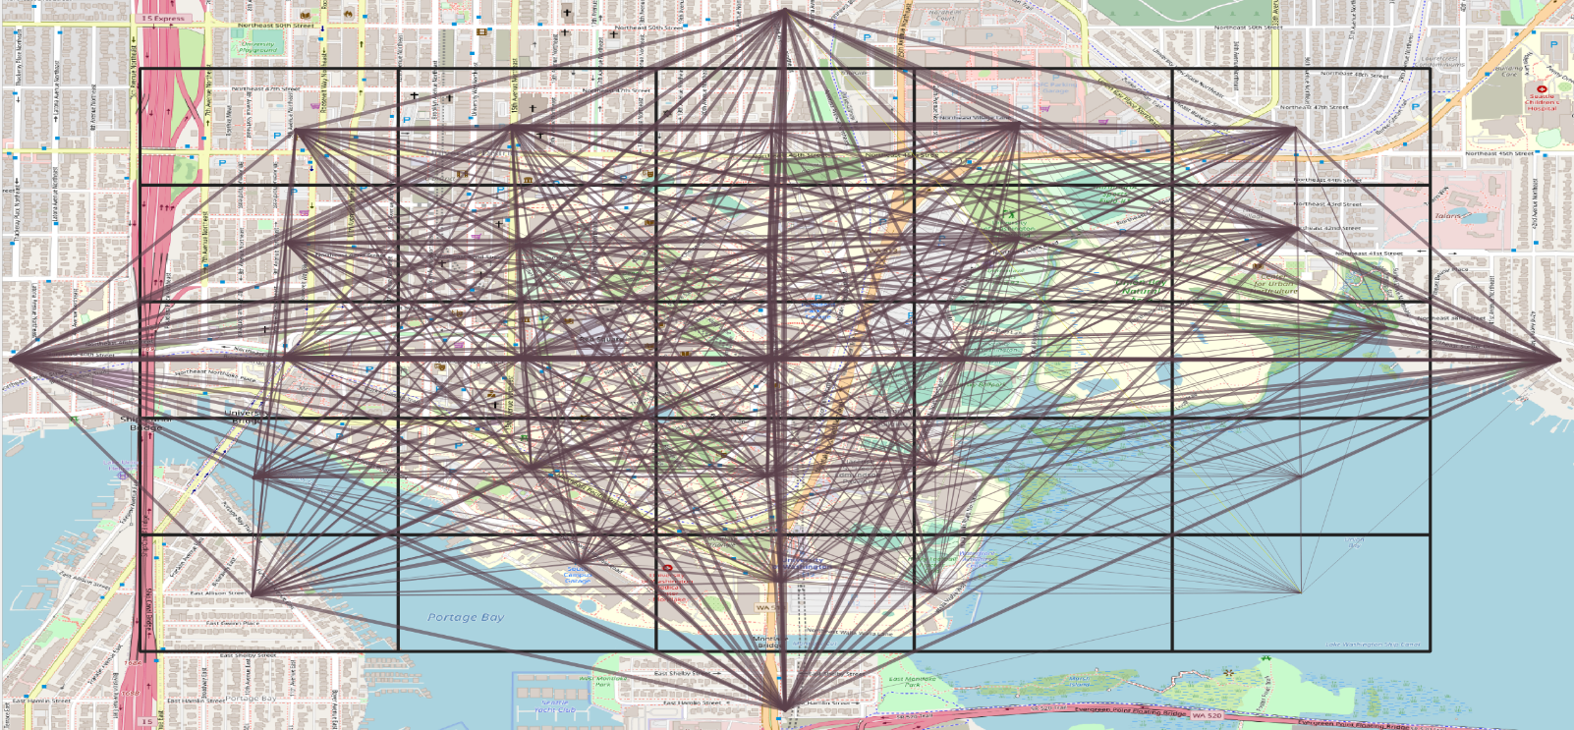

**Step 5: Execute GTFS2GMNS to get bike and walk network in GMNS format**

You only need the following 4 lines of python codes, similar to OSM2GMNS



Walk mobility network at UW (Pink)

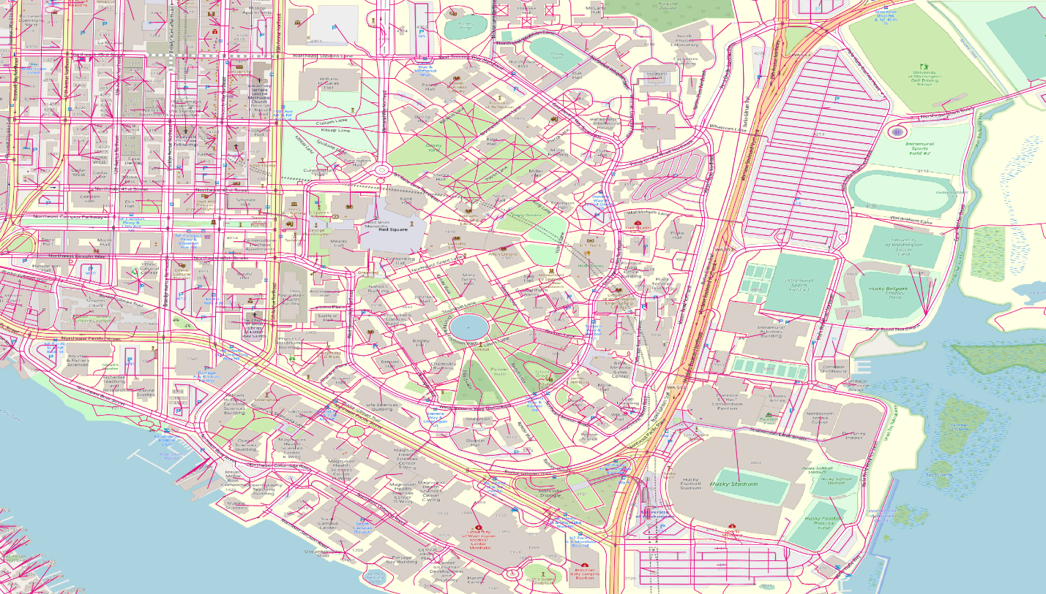

Bike mobility network at UW (Blue)

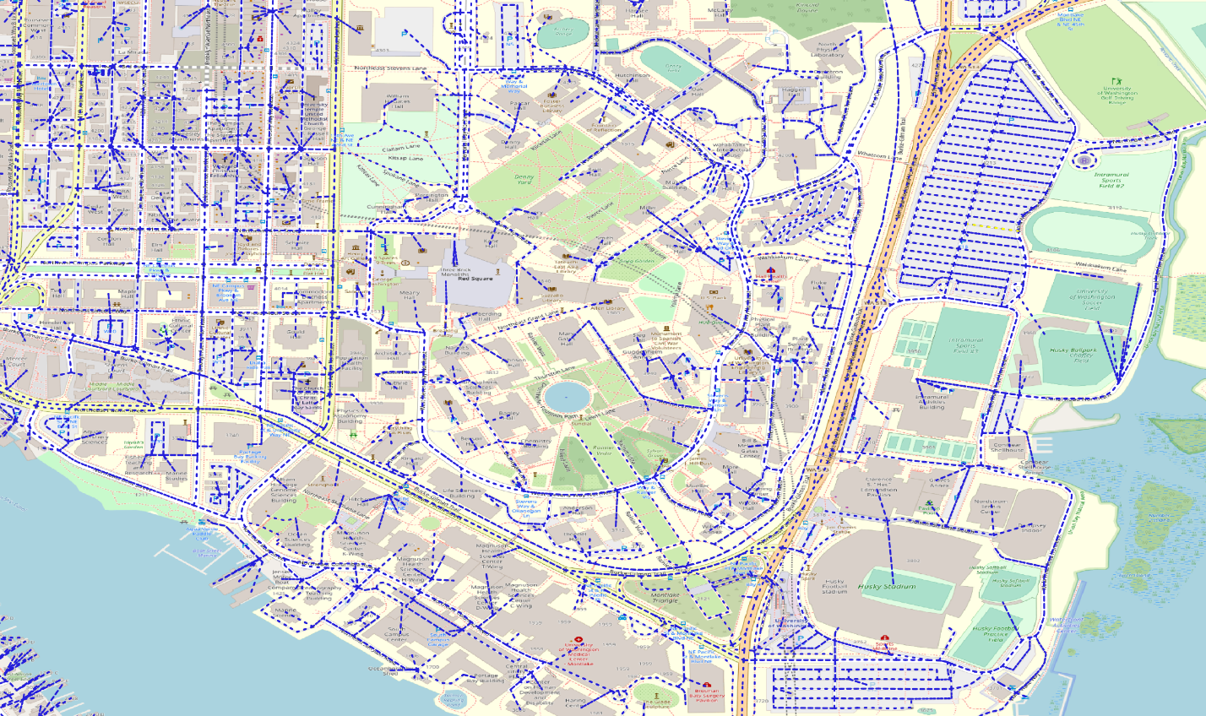

Bike + Walk

